**Name:** **Allspice,** Pimento officinalis, Pimento dioica, Clove Pepper,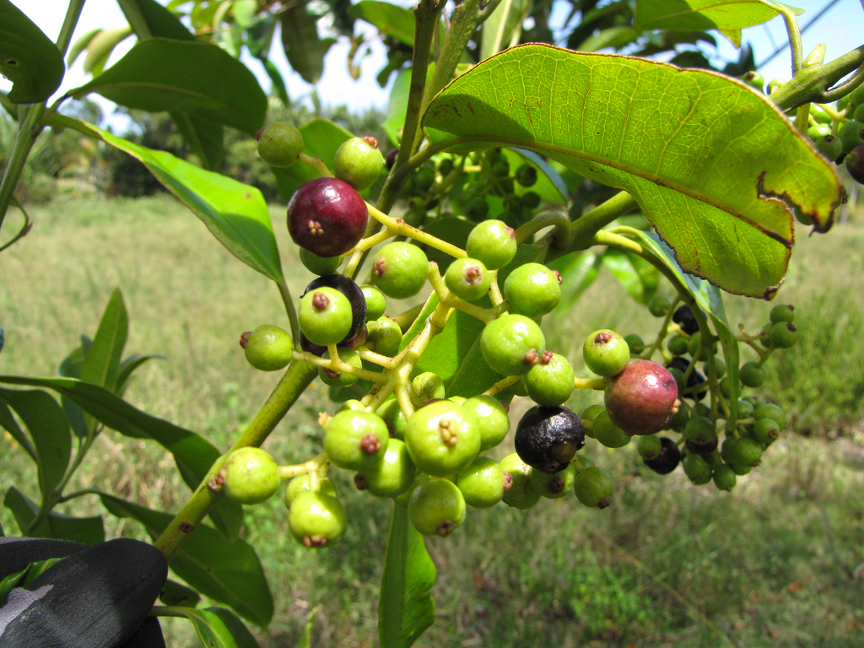 Jamaican Pepper, Myrtle Pepper, Newspice, Pimento

**Family:** Myrtaceae (Eucalyptus)

**Location:** Native to the regions of the tropical West Indies and Central and South America

**Description:** A mid canopy tree, classified as an evergreen shrub, that grows up to 59 ft in height. It can be a low scrubby bush to a tall canopy tree. Branches bear currycombs of white flowers which appear from June-August.The plant has male and female flowers born on separate trees. The common name, pimento, is derivedfrom the Spanish term for pepper, pimienta, which the berries resemble.The fruit of the tree is called allspice because its flavor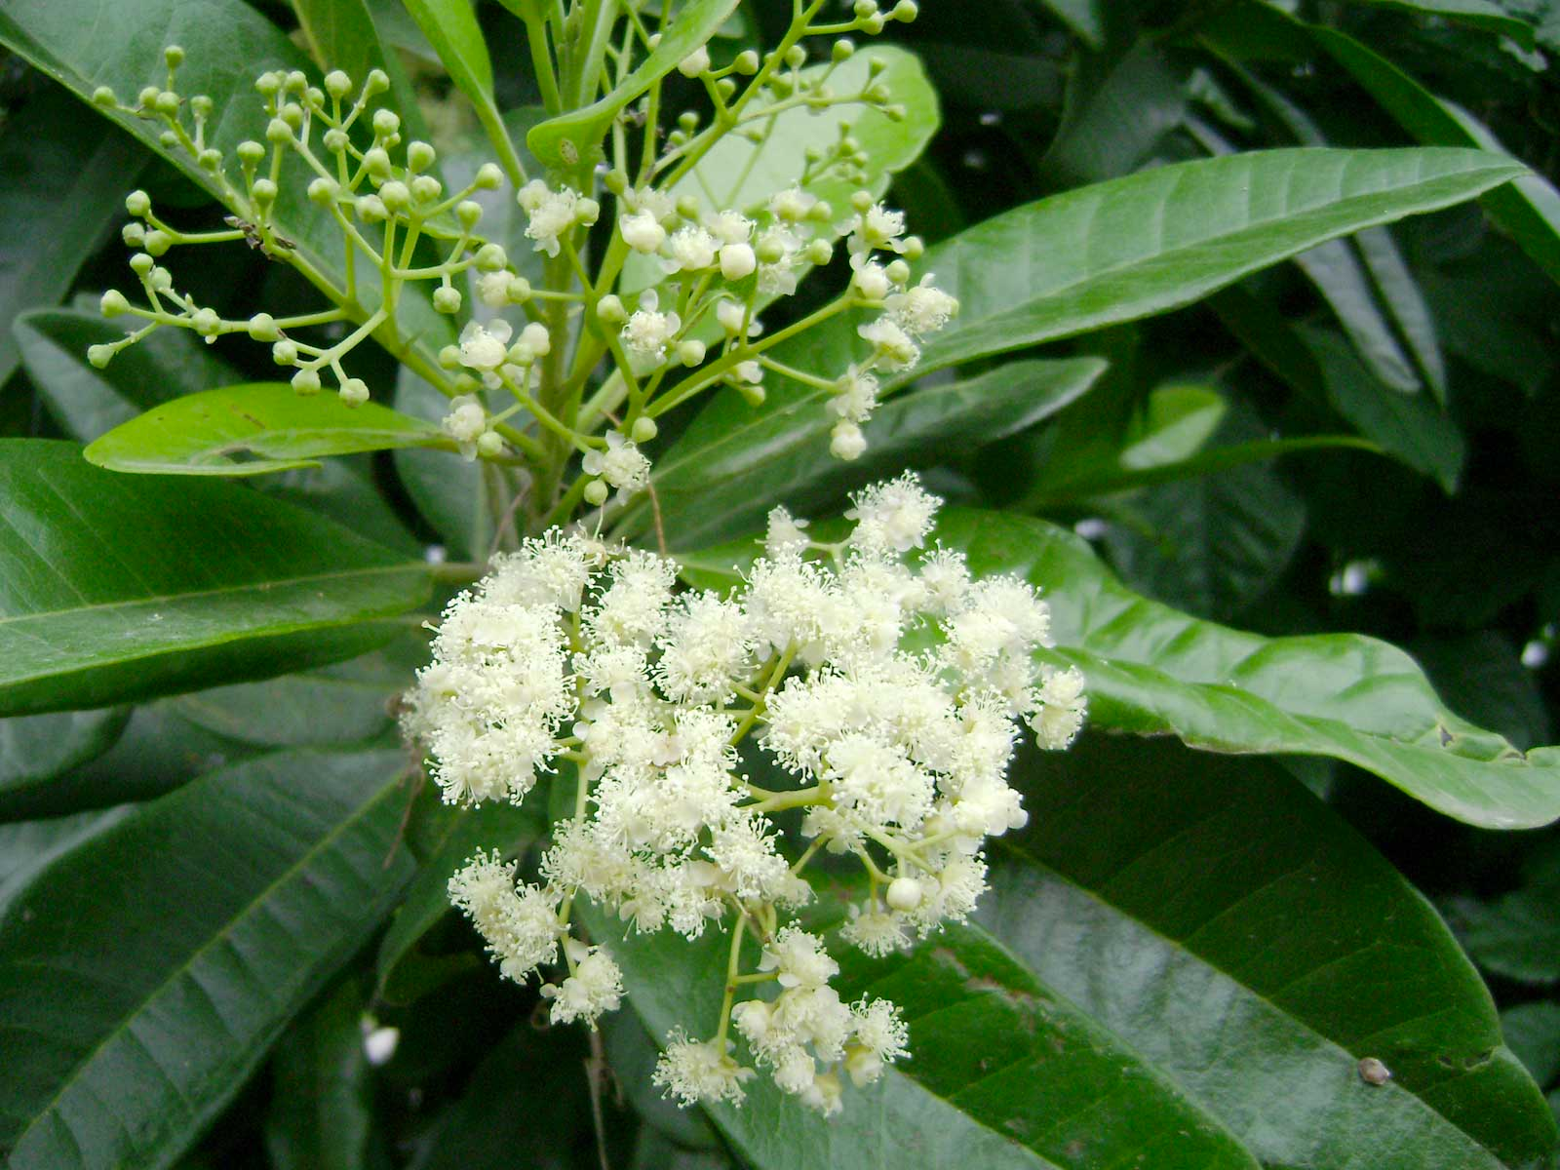 resembles a combination of cinnamon, cloves and nutmeg. The tree begins to fruit after 3 years and is in full fruit by 4 years. The fruit has two cells with a kidney shaped seed in each which distinguishes it from a pepper corn.

**Growing Conditions:** Grown outdoors in the tropics or subtropics in normal garden soil.

**Parts Used:** Dried unripe fruit

**Uses:** Poor apetite, chills, diarrhea, dyspepsia, colic, flatulence, indigestion, high blood sugar, griping, rheumatism, improves protein assimilation, prevents the buildup of gasses in the upper intestinal tract, has a warming effect (frostbite/hypothermia)

Topically: mouthwash: anesthetic on sore teeth and gums. In liniments and compresses for the pain of arthritis and neuralgia

Edible: Allspice was one of the most common culinary herbs of the Caribbean. The Aztecs used it to flavor chocolate.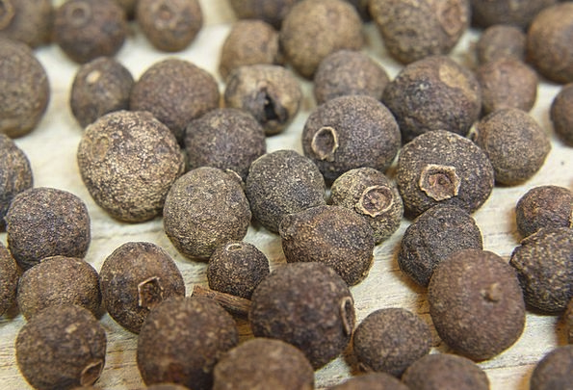

Other: in the 1800’s the Maya used allspice for embalming their dead. Because of the salmon color of the wood, it was used for making walking sticks, umbrellas, and wands. It was burned as an incense to attract prosperity and worn in medicine bags as a protective amulet. Used in perfumery.

**Actions:** Antioxidant, antiseptic, aromatic, astringent, carminative, digestive, stimulant, stomachic, styptic, rubefacient

**Constituents:** Essential Oils: eugenol, cineole, phellandrene

**Other:** Vit C, B1, B2, beta carotene, calcium, iron, magnesium, potassium, zinc

**Preparation:** the part of the berry with the strongest flavor is the shell. So be sure to grind it. Fresh leaves can be used in place of bay leaves for cooking.

**Tincture:** 30-60 drops as needed or 1-3 times a day in water  **Tea:** 1 teaspoon of crushed dried berries to one cup of boiling water. Let steep for 5-10 minutes. Drink warm.

**Pills:** 10-30 grains 1-3 times a day

**Harvest:** The inferior ovary of the flower produces a green berry which is harvested in July-August when it is unripe and dried in the sun whereupon it becomes reddish brown. If the fruit is allowed to ripen, it will loose almost all of its aromatic properties. Gathering occurs by breaking off the twigs with the bunches of berries and then laid out to dry for about 12 days being sure to protect it from moisture. Once dry the berries are removed from the twigs.

**Taste:** Bitter, Sweet

**Psychology:**

**Flower Essence:**

**Combines:** clove, nutmeg, cinnamon

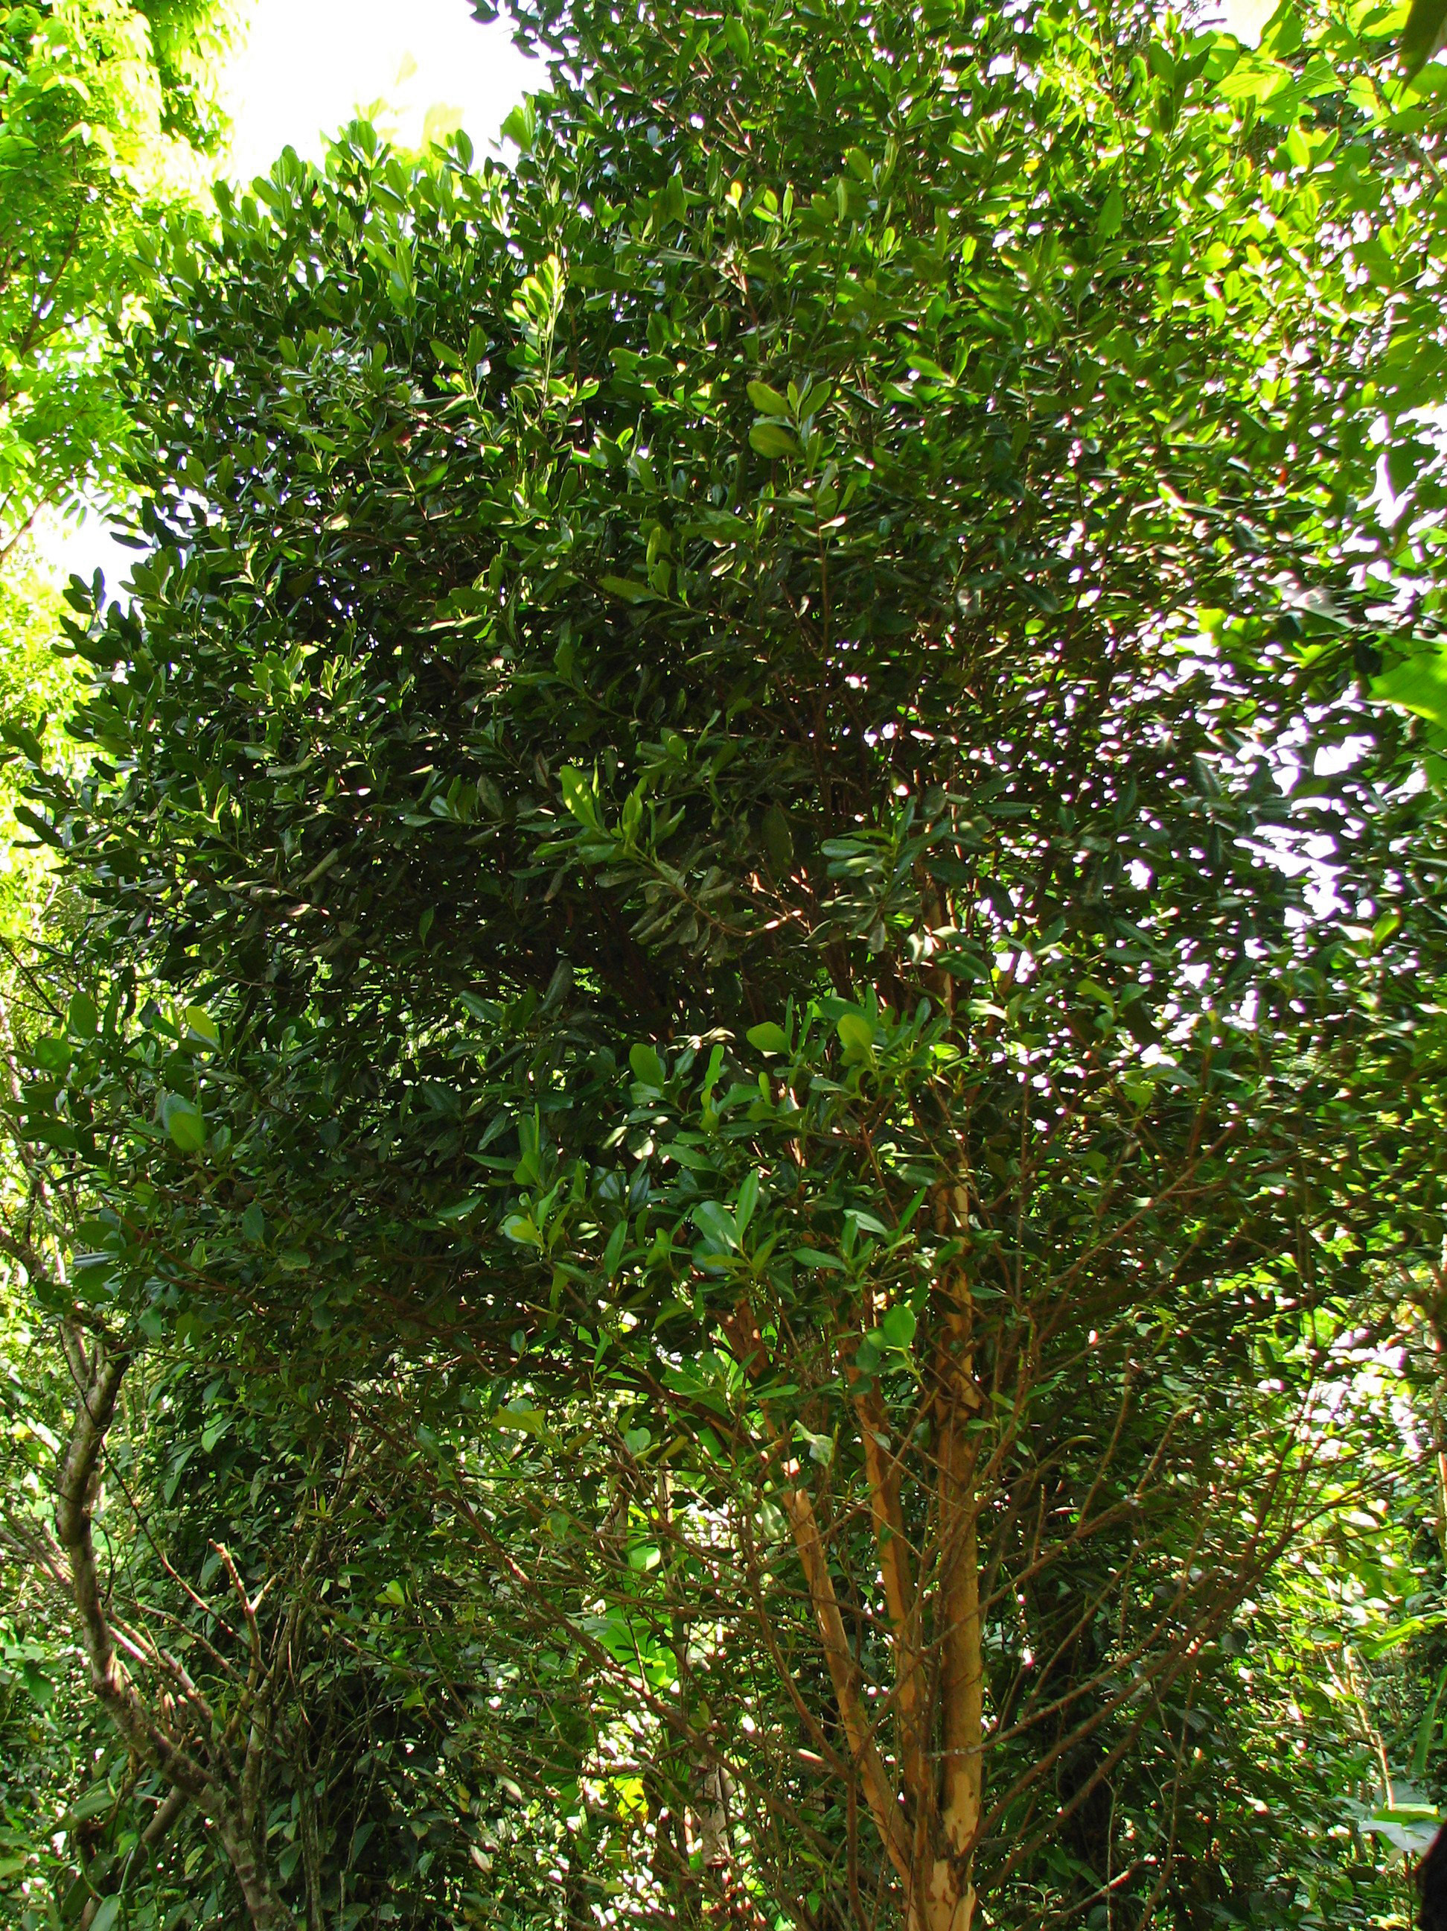**Flavor:** pungent

**Constitution:**

**Pulse:**

**Tongue:**

**Temperature:** Warm

**Moisture:** Dry

**Polarity:** Yang

**Element:** Fire

**Contra-Indications:** During pregnancy, avoid excessive use.

**References:**

***The Desktop Guide to Herbal Medicine*** by Brigitte Mars

***<https://en.wikipedia.org/wiki/Allspice>***

***The Complete Illustrated Herbal*** by David Hoffman

***<http://www.botanical.com/botanical/mgmh/a/allsp025.html>***